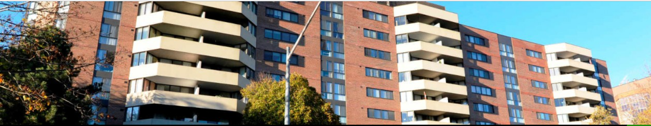

40 Baif Blvd. P-1 Party Room Rental Form

Name_________________________ Unit #________ Owner/Renter (circle one)
Address_______________________ Phone (______)______________
Date party room is required on: ____/____/____
Hours Requested: ______________________ (not later than 11:00pm)

Number in Party (30 Max.)_________

Damage deposit: $500.00
The damage deposit will be returned when the room is deemed to be in its original condition. When using the party room, owners and residents shall ensure that their guests observe the rules of YCC 471.
House rules:
-No decorations on the walls
-No smoking or vaping
-No disruptive noise levels or amplified music
-No glass in party room
-Room must be cleaned and vacated by closing time
-Any damage to property beyond $500 will be charged back to the resident/owner
No reservation is confirmed until the damage deposit fee is received. Please make cheque payable to YCC 471. The Party Room is available for the private use of the Owner, their family and guests.

I have read and agree to the above terms of YCC 471’s Party Room rental agreement.

Owner/Renter signature ____________________________ Dated ____/____/____

Please return this signed form along with your cheque directly to the 40 Baif Blvd Superintendent.

